(My notes):

1. Password
2. SHOW databases;
3. USE sakila;
4. SHOW TABLES;
5. Ctrl c *(break out)*
6. \! cls *(clear screen)*
7. DESCRIBE;
8. SELECT last_name FROM actor;
9. SELECT first_name, last_name FROM actor;
10. SELECT * FROM actor; *(selects all)*
11. SELECT first_name FROM actor WHERE first_name = 'JOHN'; *(condition)*
12. SELECT * FROM actor WHERE first_name LIKE '%p';
13. SELECT * FROM actor WHERE first_name LIKE 'a%';
14. SELECT *

-> FROM actor

-> ORDER BY first_name ASC

-> LIMIT 10;

1. SELECT title, release_year, language_id

-> FROM film

-> WHERE language_id = (SELECT language_id FROM language WHERE name = 'English');

1. SELECT f.title, f.release_year, f.language_id

-> FROM film f

-> JOIN language l ON f.language_id = l.language_id

-> WHERE l.name = 'English';

1. SELECT c.first_name, c.last_name, f.title, p.amount

-> FROM customer c

-> JOIN rental r ON c.customer_id = r.customer_id

-> JOIN payment p ON r.rental_id = p.rental_id

-> JOIN inventory i ON r.inventory_id = i.inventory_id

-> JOIN film f ON i.film_id = f.film_id

-> ORDER BY p.amount DESC

-> LIMIT 5;

**Questions from 1-9.**

1. Return all actors whose last names are ALLEN from the actor table

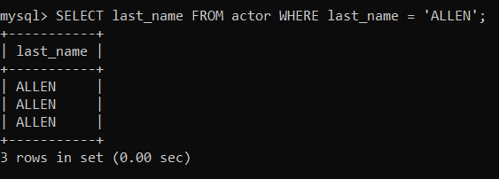

1. Return all the actors who’s last_name column has a value DAVIS, and the row’s first_name has a value SUSAN.

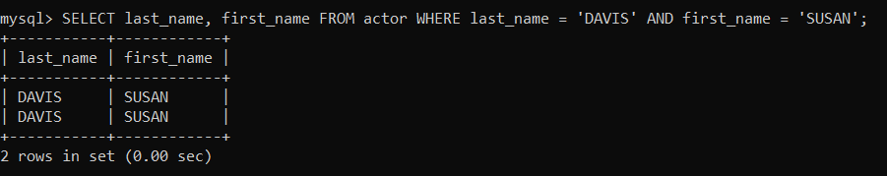

1. Return all actors where last_name column has a value ALLEN or DAVIS.

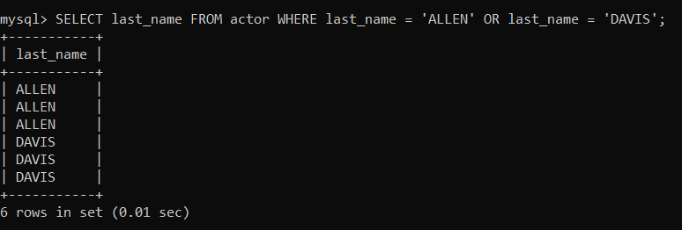

1. Return the number of categories which have a name that does not start with the letter A.

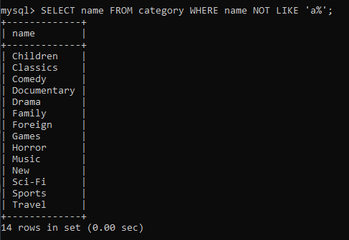

1. Return all actor names and the name of each film title they were in.

1. Return the title, release year, and category of all movies.

1. Return how much JOHNNY TURPIN has spent on movie rentals.

1. Return the name of the customer that has spent the most of movie rentals, include the amount they have spent.

1. Return all movie title, release year, actor name and category where the actor first_name is ‘Sean’

1. 10 challenging SQL statements (Just select, no create, update or delete statements)**.**

**My own exercises:**

1. Find the names of the actors who have appeared in more than 10 films, along with the number of films they have appeared in.

1. Find the number of rentals for each customer, including the customer’s name and email address.

1. Find the names of the customers who have rented a movie in the month of February 2006.

1. Get the total number of rentals for each movie sorted in descending order.

1. Find the names of all customers who have rented more than 10 movies in total and sort them in descending order.

1. Find the movies that have been rented by customer with ID 1.

1. Find the movies that have neem rented more than 30 times.

1. Find the titles of all movies that have been rented by a customer whose last name starts with ‘S2’.

1. Find the titles and release years of all films in the "Horror" category.

1. Find the names of the customers that have rented a movie in the year 2006.

